**VIS!00**

**B00LEO GAME PROJECT**



**MADE BY**

Vis!00

**REPOSITORY**

Vis100

Table of contents

**VIS!00** 1

TABLE OF CONTENTS 2

PROJECT IDEA 3

TEAM MEMBERS 3

STAGES OF THE PROJECT 3

PERFORMED TASKS 3

BLOCK DIAGRAM 4

FUTURE IDEAS 4

PROJECT IDEA

**The goal of the project is to create a game based on Boolean logic-B00LE0.**

TEAM MEMBERS

|  |  |
| --- | --- |
| Name | Role in the team |
| Lubomir Georgiev | Scrum Trainer |
| Ivailo Stoqnov | Back-end developer |
| Georgi Kotakov | Front-end developer |
| Denislav Bratoevski | QA engineer |

STAGES OF THE PROJECT

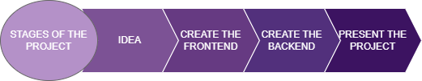

PERFORMED TASKS

|  |  |
| --- | --- |
|  | Performed tasks |
| 1 | Create the first stage of the backend  The design was created so that users can easily navigate through the site and find what they are searching for. |
| 2 | Create a main menu  On our main menu you have an option to play the game, configure the settings, see the game rules, and quit the game |
| 3 | Create the game structure  The game features four stages which you can choose from |
| 4 | Create the rules tab  In the rules tab you can see the rules of the game |
| 5 | Create the settings tab  In the settings tab you can configure the games settings |
| 6 | Create the projects README  In the README of our project you can see a brief description of our project |
| 7 | Last touches  In the end we created the Documents and Wiki of our project. |

BLOCK DIAGRAM

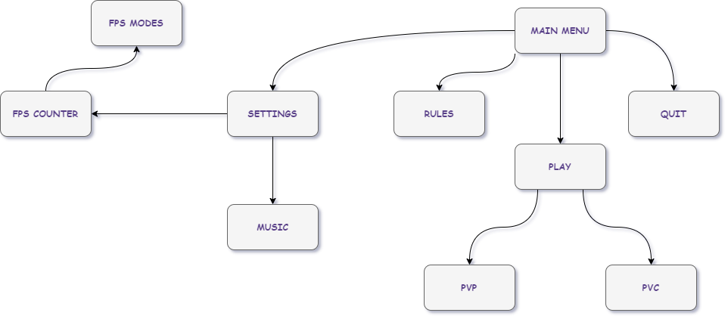

FUTURE IDEAS

|  |  |
| --- | --- |
|  | Future ideas |
| 1 | Create stage 3 and stage 4 |
| 2 | Create a play mode where you can play from other devices |
| 3 | Create a login form with SQL |